PROJECT REPORT
Wireless Gesture-Controlled Robotic Arm using Flex Sensors

Aim:
To design and implement a wireless gesture-controlled robotic arm using flex sensors and ESP32 microcontrollers.

Apparatus / Components Required:
- ESP32 (2 units)
- Flex Sensors
- Servo Motors
- PCA9685 PWM Driver Module
- 18650 Li-ion Batteries
- Buck Converter (5V regulation)
- Breadboard / Zero PCB
- Connecting Wires

Theory (Detailed Explanation):
This project is based on the concept of gesture-based human-machine interaction, where human hand movements are used to control a robotic system.

1. Flex Sensor
A flex sensor is a variable resistor:
- Straight → low resistance
- Bent → high resistance
This change in resistance is converted into a voltage signal using a voltage divider circuit. The ESP32 reads this voltage using its ADC and determines how much the finger is bent.

2. ESP32 Microcontroller
ESP32 acts as the control unit:
- Reads analog sensor data
- Sends/receives data wirelessly
- Controls output devices
It has built-in Wi-Fi and supports ESP-NOW protocol.

3. ESP-NOW Communication
ESP-NOW is a wireless protocol:
- Direct device-to-device communication
- No router required
- Low latency
Used to send sensor data from transmitter to receiver ESP32.

4. I2C Protocol
I2C is used to communicate between ESP32 and PCA9685:
- SDA → Data line
- SCL → Clock line
- Only 2 wires needed

5. PCA9685 PWM Driver
- Controls up to 16 servos
- Generates PWM signals
- Reduces load on ESP32

6. Servo Motors
- Rotate based on PWM signal
- Used in robotic arm joints
- Replicate finger movement

7. System Architecture Design (Important)
The system is intentionally designed as:
- Transmitter → Only reads and sends data
- Receiver → Processes and controls actuators

Block Diagram:
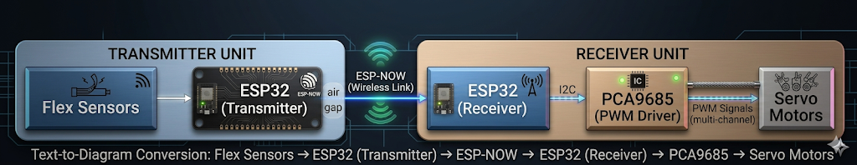

Working Principle (Step-by-Step):
- Flex sensors detect finger bending
- Resistance changes → voltage changes
- ESP32 reads voltage via ADC
- Transmitter sends raw data using ESP-NOW
- Receiver ESP32 receives data
- Maps values to servo angles
- Sends commands to PCA9685 via I2C
- PCA9685 generates PWM signals
- Servo motors move accordingly

Circuit Description:
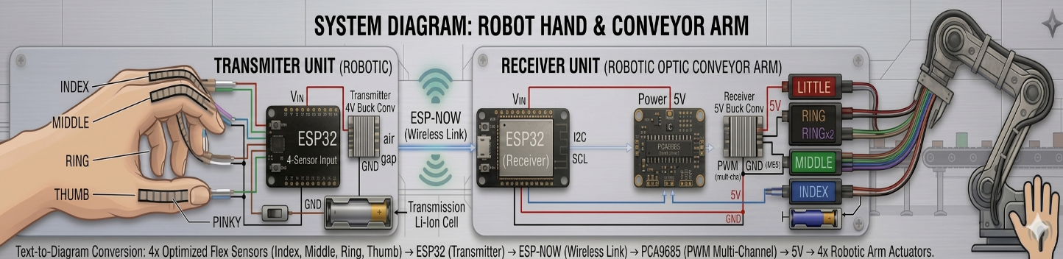

🔹 Flex Sensor Circuit
- Connected as voltage divider
- Output connected to ESP32 ADC pin
🔹 ESP32 to PCA9685
- SDA → Data
- SCL → Clock
🔹 PCA9685 to Servo
- PWM output to servo signal pin
🔹 Power System
- 18650 batteries used
- Buck converter regulates to 5V
- Servos require stable current supply

Procedure:
- Connect flex sensors to ESP32 ADC pins
- Write code to read analog values
- Implement ESP-NOW communication
- Interface PCA9685 with receiver ESP32
- Connect servos to PCA9685
- Power system using battery and buck converter
- Test gesture-based control

Code Implementation:
The firmware is divided into two modules:
1. Transmitter Code (Glove Unit)
- Reads analog values from flex sensors
- Sends raw data using ESP-NOW
- No mapping done (keeps design simple)
View Transmitter Code (ESP32):
2. Receiver Code (Robotic Arm Unit)
- Receives data via ESP-NOW
- Maps values to servo angles
- Communicates with PCA9685 using I2C
- Controls servo motors
View Receiver Code (ESP32 + PCA9685):

Programming Details:
- Language: Embedded C (Arduino Framework)
- IDE: Arduino IDE
- Protocols:
  - ESP-NOW (Wireless)
  - I2C (Servo control)

Observations:
- Real-time gesture control achieved
- Wireless communication worked smoothly
- Servo response matched finger movement
- Minor jitter observed in servo movement

Result:
The wireless gesture-controlled robotic arm was successfully implemented and demonstrated. The system worked effectively at the prototype stage.

Challenges Faced:
🔸 Servo Jitter
- Caused by unstable power supply
- Breadboard connections introduced noise
🔸 Flex Sensor Damage
- Hot glue damaged sensing layer
- Reduced sensor performance
🔸 Analog Noise
- Slight fluctuations in readings

Precautions:
- Avoid applying heat on flex sensors
- Use proper mounting methods (tape/clamps)
- Ensure stable power supply
- Avoid loose connections
Improvements:
- Use PCB instead of breadboard
- Add capacitors for filtering
- Improve sensor mounting

Applications:
- Prosthetic hand systems
- Robotics control
- Industrial automation
- Human-machine interfaces

Conclusion:
The project successfully demonstrates a wireless gesture-controlled robotic system using embedded technologies. It highlights the importance of communication protocols, power stability, and mechanical design in real-world applications.

